# To Supply Leftover Food To Poor ( FOOD CONNECT )

**By**

## 1.SYAM DAVINCY C (au715021104039)

## 2.AJAY S (au715021104003)

## 3.KESAVABOOPATHI S (au715021104017)

## 4.PINGILI AYYAPPA (au715021104029)

## NM_ID: 9098B5707EEB14DAFE84AD708A756AED

## COLLEGE NAME:SUGUNA COLLEGE OF ENGINEERING

# Project Abstract

This project aims to address both food waste and food insecurity, often found in the same communities, by creating a solution that tackles both issues simultaneously. We plan to connect surplus food suppliers, such as local restaurants, grocery stores, and food producers, with individuals and families in need. By partnering with these suppliers, we'll collect food that is still good to eat but would otherwise be discarded and redistribute it to those who lack adequate access to nutritious meals.

Our initiative will not only reduce food waste but also provide essential nourishment to people facing food insecurity. We'll establish a system for efficiently collecting, storing, and distributing food with the help of volunteers and community organizations. Additionally, this project will raise awareness about food waste and encourage community engagement in the fight against hunger.

The ultimate goal is to create a model that can be replicated in other communities, fostering a culture of sharing and support. By bridging the gap between food waste and those in need, our project seeks to reduce hunger and prevent deaths caused by food scarcity.

# Index

**TOPIC PAGE NO.**

1. Introduction 04-05
2. Tasks to set up the App 05-39
3. Conclusion 40

# Introduction

The "Supply Leftover Food to the Poor" project, known as "Food Connect," tackles two significant global issues: food waste and hunger. Our initiative is focused on efficiently redistributing leftover food to those in need, using advanced tools to manage venues, tasks, volunteers, and distribution points.

"Food Connect" aims to ensure that surplus food from restaurants, events, and households is collected and redistributed to underprivileged communities. Leveraging Salesforce's data management and process automation capabilities, we will track food donations, coordinate volunteer efforts, and optimize delivery routes to ensure that no food is wasted and no one goes hungry.

### Key Features of Food Connect:

* **Real-Time Tracking:** Enables the monitoring of food donations and deliveries in real-time, ensuring that surplus food is quickly redistributed.
* **Volunteer Management:** Streamlines the management of volunteer sign-ups, scheduling, and task assignments to maximize impact.
* **Automated Notifications:** Sends automated alerts to donors, volunteers, and recipients about when food will be collected and delivered.
* **Data Analytics:** Utilizes analytics to identify trends, optimize delivery routes, and improve the efficiency of the food redistribution process.
* **Community Engagement:** Encourages local businesses, organizations, and individuals to join the fight against hunger.

### Our Mission:

To reduce food waste and alleviate hunger through a sustainable, efficient redistribution system. We connect surplus food with those in need, making a significant difference in food security and community well-being.

# Tasks to set up FoodConnect

**Task 1 :** Salesforce developer account creation

Creating a developer org in salesforce.

1. Go to<https://developer.salesforce.com/signup>
2. On the sign up form, enter the required details
3. Go to the inbox of the email that you used while signing up. Click on the verify account to activate your account. The email may take 5-10 mins.

**Task 2 :** Object

Navigate to the Setup page:

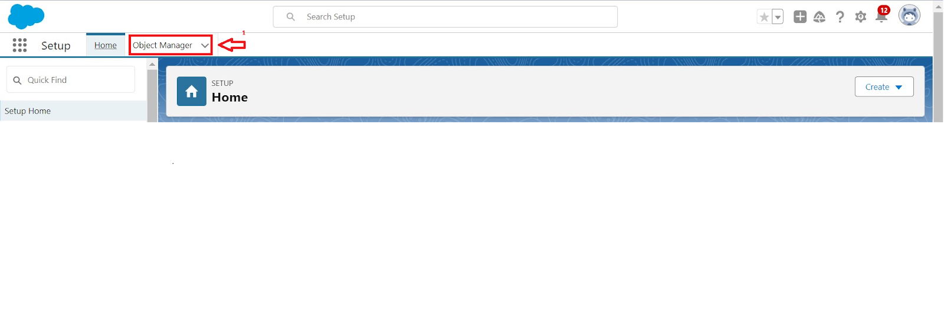

To create an object:

1. From the setup page > Click on Object Manager > Click on Create > Click on Custom Object.

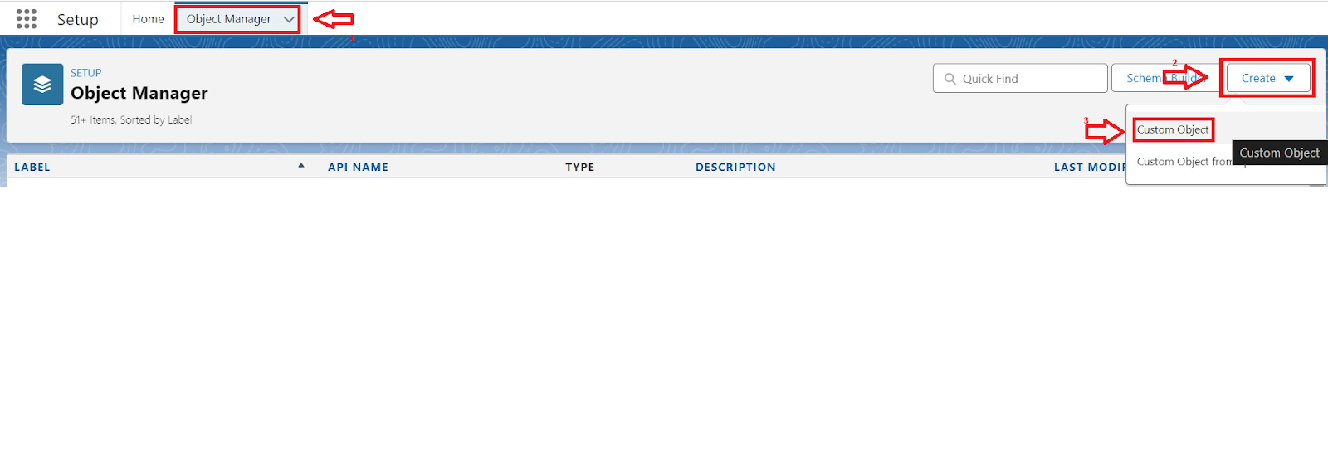

1. On the Custom object defining page:
2. Enter the label name, plural label name, click on Allow reports, Allow search.

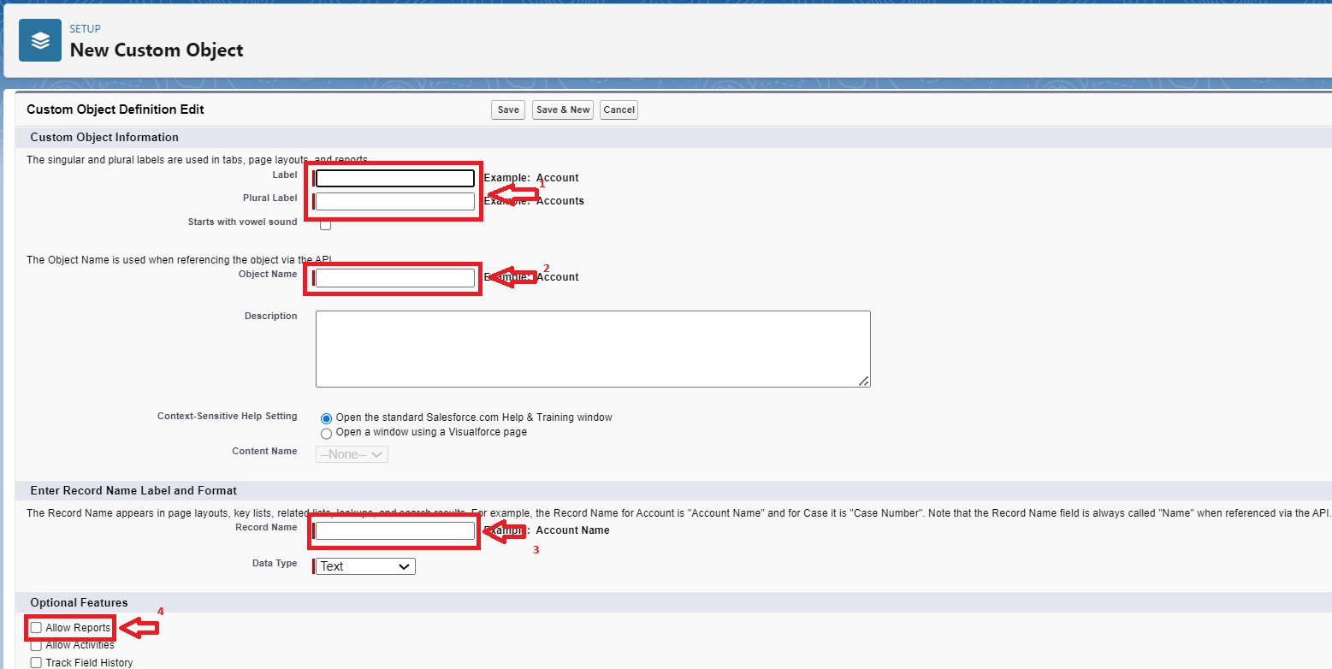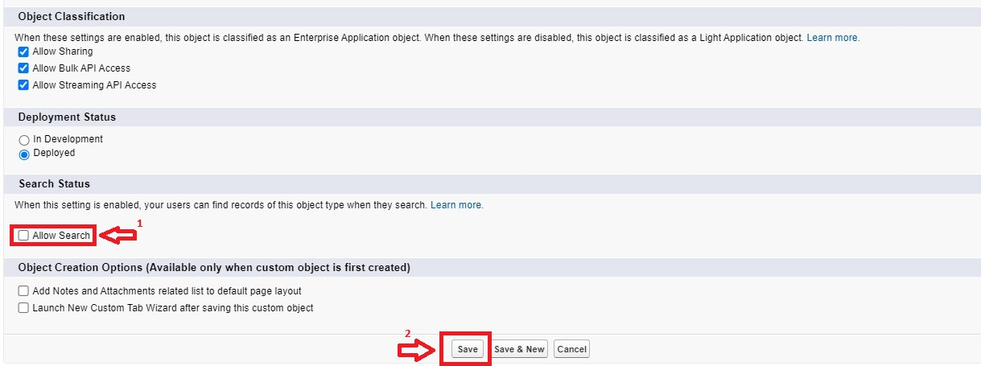

1. Click on Save.

**Task 2 a :** Create Venue Object

To create an object:

1. From the setup page >> Click on Object Manager >> Click on Create >>Click on Custom Object.
   1. Enter the label name >> Venue
   2. Plural label name >> Venues
   3. Enter Record Name, Label, and Format
      * Record Name >> Venue Name
      * Data Type >> Text
2. Click on Allow reports and Track Field History,Allow Activities.
3. Allow search >> Save.

**Task 2 b :** Create Drop-Off Point Object

To create an object:

1. From the setup page >> Click on Object Manager >> Click on Create >> Click on Custom Object.
   1. Enter the label name >> Drop-Off Point
   2. Plural label name>> Drop-Off Points
   3. Enter Record Name, Label, and Format
      * Record Name >> Drop-Off point Name
      * Data Type >> Text
2. Click on Allow reports and Track Field History,Allow Activities
3. Allow search >> Save.

**Task 2 c :** Create Task Object

To create an object:

1. From the setup page >> Click on Object Manager >> Click on Create >> Click on Custom Object.
   1. Enter the label name>> Task
   2. Plural label name>> Tasks
   3. Enter Record Name, Label, and Format
      * Record Name >> Task Name
      * Data Type >> Text
2. Click on Allow reports and Track Field History,Allow Activities
3. Allow search >> Save.

**Task 2 d :** Create Volunteer Object

To create an object:

1. From the setup page >> Click on Object Manager>> Click on Create >> Click on Custom Object.
   1. Enter the label name>> Volunteer
   2. Plural label name>> Volunteers
   3. Enter Record Name, Label, and Format
      * Record Name >> Volunteer Name
      * Data Type >> Text
2. Click on Allow reports and Track Field History, Allow Activities
3. Allow search >> Save.

**Task 2 e :** Create Execution Details Object

To create an object:

1. From the setup page >> Click on Object Manager >> Click on Create >> Click on Custom Object.
   1. Enter the label name >> Execution Detail
   2. Plural label name >> Execution Details
   3. Enter Record Name, Label, and Format
      * Record Name >> Execution Detail Name
      * Data Type >> Text
2. Click on Allow reports and Track Field History, Allow Activities
3. Allow search >> Save.

**Task 3 :** Tabs

What is Tab :

A tab is like a user interface that is used to build records for objects and to view the records in the objects.

Creating a Custom Tab

To create a Tab:(Venue)

1. Go to the setup page >> type Tabs in the Quick Find bar >> click on tabs >> New (under the custom object tab)

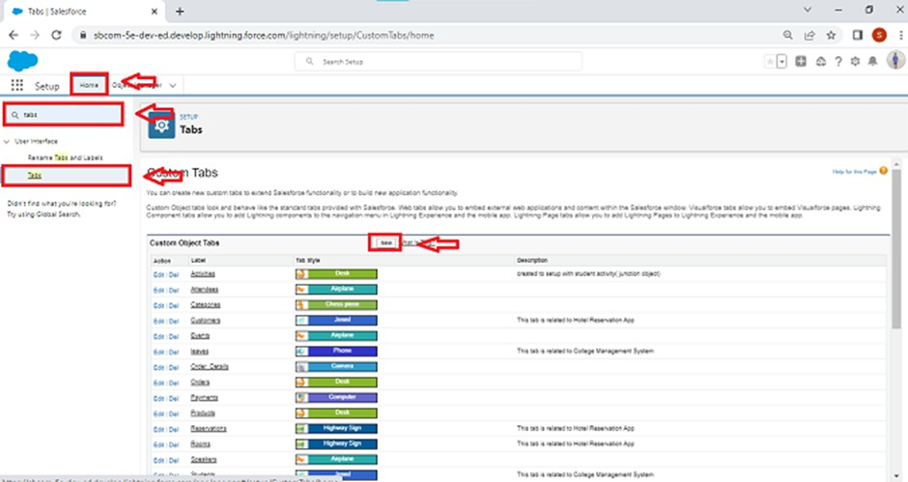

1. Select Object(Venue) >> Select the tab style >> Next (Add to profiles page) keep it as default >> Next (Add to Custom App) uncheck the include tab .
2. Make sure that the Append tab to users' existing personal customizations is checked.
3. Click save

Creating Remaining Tabs

1. Now create the Tabs for the remaining Objects; they are “Drop-Off Point, Task, Volunteer, Execution Details”.
2. Follow the same steps as mentioned above in creating a custom tab.

**Task 4 :** The Lightning App

To create a lightning app page:

1. Go to the setup page >> search “app manager” in quick find >> select “app manager” >> click on New lightning App.

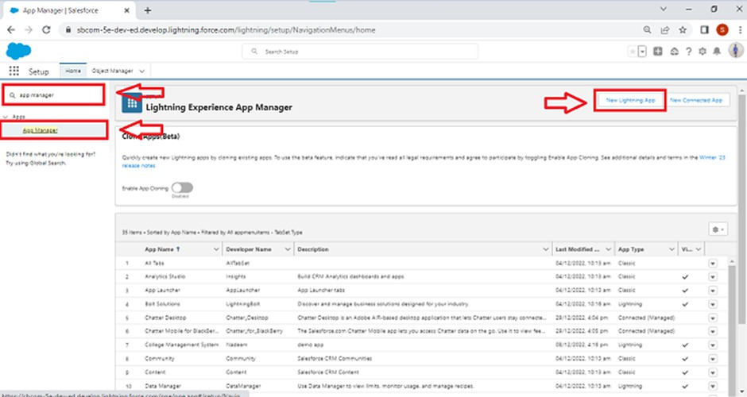

1. Fill the app name in app details and branding as follow App Name : Food Connect, Developer Name : This will auto be populated

, Image : optional (if you want to give any image, you can otherwise not mandatory), Primary color hex value : keep this default.

1. Then click Next >> (App option page)Set Navigation Style as Standard Navigation >> Next.

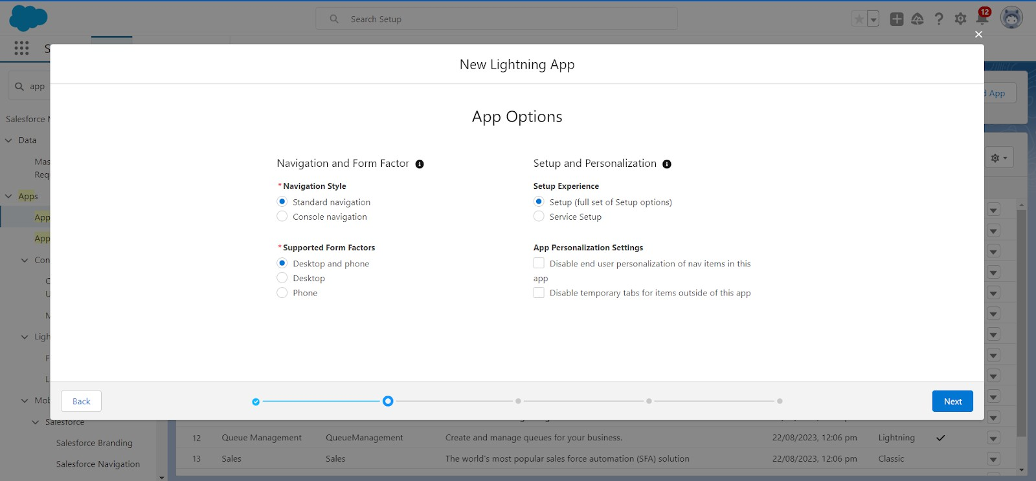

4.(Utility Items) keep it as default >> Next.

1. To Add Navigation Items:

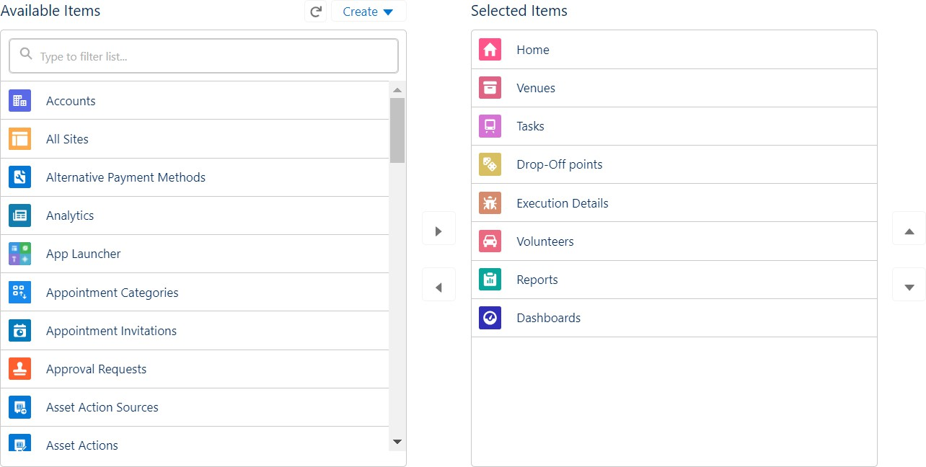

Search for the item in the (Home, Venue, Drop-Off Point, Task, Volunteer, Execution Details, Reports) from the search bar and move it using the arrow button >> Next >> Next.

1. To Add User Profiles:

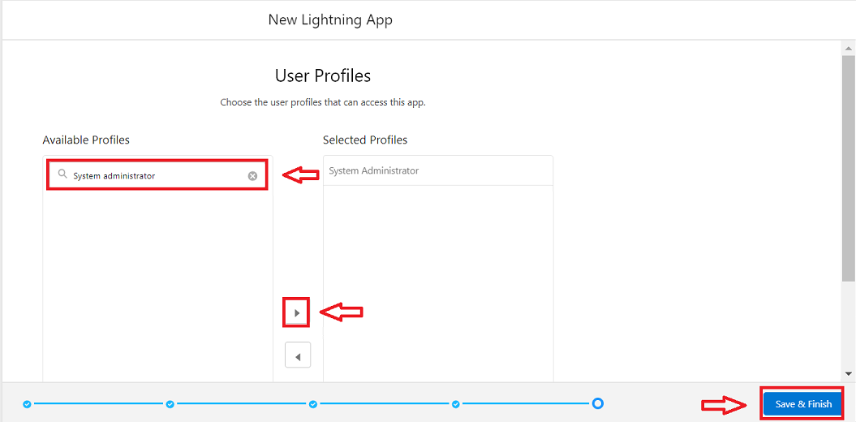

Search profiles (System administrator) in the search bar >> click on the arrow button >> save & finish.

**Task 5 :** Fields

## Task 5 a :Creation of Lookup Relationship Field on Volunteer

1. Go to setup >> click on Object Manager >> type object name(Volunteer) in the search bar >> click on the object.

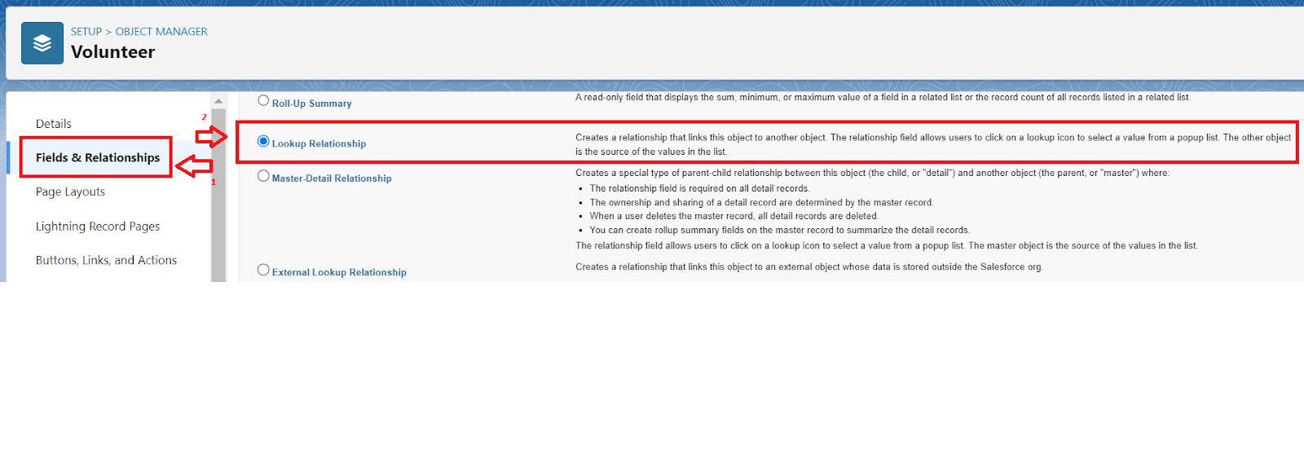

1. Now click on “Fields & Relationships” >> New
2. Select Master Detail relationship
3. Select the related object “Drop-Off point” and click next.

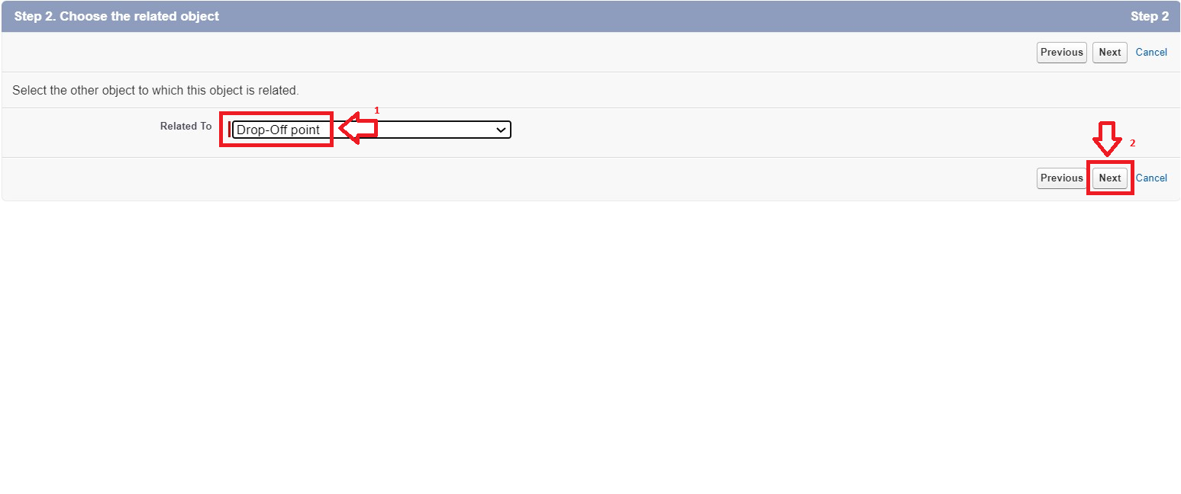

1. Field Name : Drop_Off_point
2. Field label : Auto generated
3. Next >> Next >> Save.

Creation of Master Detail Relationship Field onExecution DetailsObject :

1. Go to setup >> click on Object Manager >> type object name(Execution Details) in the search bar >> click on the object.
2. Now click on “Fields & Relationships” >> New
3. Select Master Detail relationship
4. Select the related object “Volunteer” and click next.
5. Field Name : Volunteer
6. Field label : Auto generated
7. Next >> Next >> Save.

Creation of Master Detail Relationship Field onExecution DetailsObject :

1. Go to setup >> click on Object Manager >> type object name(Execution Details) in the search bar >> click on the object.
2. Now click on “Fields & Relationships” >> New
3. Select Master Detail relationship
4. Select the related object “Task” and click next.
5. Field Name : Task
6. Field label : Auto generated
7. Next >> Next >> Save.

Creation of Lookup Relationship Field onDrop-Off PointObject :

1. Go to setup >> click on Object Manager >> type object name(Task) in the search bar >> click on the object.
2. Now click on “Fields & Relationships” >> New
3. Select Lookup relationship
4. Select the related object “Drop-Off Point” and click next.
5. Field Name : Venue
6. Field label : Venue c
7. Next >> Next >> Save.

Creation of Lookup Relationship Field onTaskObject :

1. Go to setup>> click on Object Manager >> type object name(Task) in the search bar >> click on the object.
2. Now click on “Fields & Relationships” >> New
3. Select Lookup relationship
4. Select the related object “Venue” and click next.
5. Field Name : Sponsored By
6. Field label : Auto generated
7. Next >> Next >> Save.

Creation of Lookup Relationship Field onTaskObject :

1. Go to setup>> click on Object Manager >> type object name(Task) in the search bar >> click on the object.
2. Now click on “Fields & Relationships” >> New
3. Select Lookup relationship
4. Select the related object “Drop-Off point” and click next.
5. Field Name : Drop-Off point
6. Field label : Auto generated
7. Next >> Next >> Save.

## Task 5 b : Creation of fields for the Venue object

1. Go to setup>> click on Object Manager >> type object name(Venue) in search bar >> click on the object.
2. Now click on “Fields & Relationships” >> New
3. Select Data type as an “Email” and Click on Next
4. Fill the Above as following:
   * Field Label : Contact Email
   * Field Name : Contact Email
   * Click on required check box
   * Click on Next >> Next >> Save and new.

To create another fields in an object:

1. Go to setup >> click on Object Manager >> type object name(Venue) in search bar >> click on the object.
2. Now click on “Fields & Relationships” >> New
3. Select Data type as a “Phone” and Click on Next
4. Fill the Above as following:
   * Field Label : Contact Phone
   * Field Name : Contact Phone
   * Click on required check box
   * Click on Next >> Next >> Save and new.

To create another fields in an object:

1. Go to setup >> click on Object Manager >> type object name(Venue) in search bar >>click on the object.
2. Now click on “Fields & Relationships” >> New
3. Select Data type as a “Geolocation” and Click on Next
4. Fill the Above as following:
   * Field Label : Location
   * Decimal Places : 4
   * Field Name : Location
   * Description : Enter the Geolocation of your Venue
   * Click on Next >> Next >> Save and new.

To create another fields in an object:

1. Go to setup >> click on Object Manager >> type object name(Venue) in search bar >> click on the object.
2. Now click on “Fields & Relationships” >> New
3. Select Data type as a “Long Text Area” and Click on Next
4. Fill the Above as following:
   * Field Label : Venue Location
   * Field Name : Venue_Location
   * Click on Next >> Next >> Save and new.

## Task 5 c : Creation of fields for the Drop-Off point object

Go to setup >> click on Object Manager >> type object name(Drop-Off point) in search bar >> click on the object.

1. Now click on “Fields & Relationships” >> New
2. Select Data type as a “Geolocation” and Click on Next
3. Fill the Above as following:
   * Field Label : Location 2
   * Field Name : gets auto generated
   * Description : Enter the Geolocation of the Drop off Point
   * Geolocation Options : select Decimal
   * Decimal Places : 4
   * Click on Next >> Next >> Save and new.

To create another fields in an object:

1. Go to setup >> click on Object Manager >> type object name(Drop-Off point) in search bar >> click on the object.
2. Now click on “Fields & Relationships” >> New
3. Select Data type as a “Formula” and Click on Next
4. Fill the Above as following:
   * Field Label : distance calculation
   * Field Name : distance_calculation
   * Formula Return Type : Number
   * Formula Options : DISTANCE( Location_2 c , Venue r.Location c , 'km')
   * Click on Next >> Next >> Save and new.

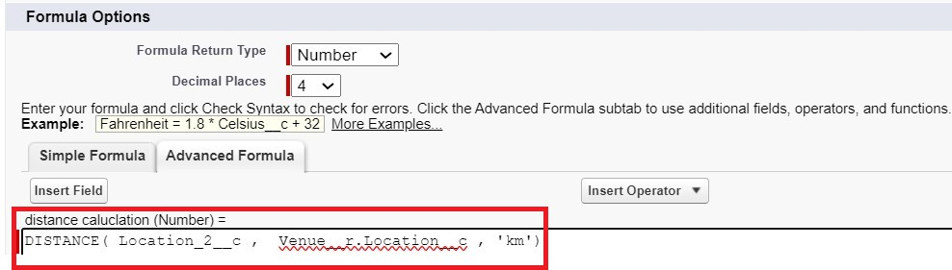

To create another fields in an object:

1. Go to setup >> click on Object Manager >> type object name(Drop-Off point) in search bar >> click on the object.
2. Now click on “Fields & Relationships” >> New
3. Select Data type as a “Picklist” and Click on Next
4. Fill the Above as following:
   * Field Label : State
   * Field Name : State
   * Enter values, with each value separated by a new line :

Andhra Pradesh Arunachal Pradesh Assam

Bihar Chhattisgarh Goa

Gujarat Haryana

Himachal Pradesh Jharkhand Karnataka

Kerala Maharashtra Madhya Pradesh Manipur Meghalaya Mizoram Nagaland Odisha

Punjab Rajasthan Sikkim Tamil Nadu Tripura Telangana

Uttar Pradesh Uttarakhand West Bengal

Andaman & Nicobar (UT) Chandigarh (UT)

Dadra & Nagar Haveli and Daman & Diu (UT) Delhi [National Capital Territory (NCT)] Jammu & Kashmir (UT)

Ladakh (UT) Lakshadweep (UT) Puducherry (UT)

* + Click on required check box
  + Click on Next >> Next >> Save and new.

To create another fields in an object:

1. Go to setup >> click on Object Manager >> type object name(Task) in search bar

>> click on the object.

1. Now click on “Fields & Relationships” >> New
2. Select Data type as a “Number” and Click on Next
3. Fill the Above as following:
   * Field Label : Distance
   * Field Name : Distance
   * Length: 14
   * Decimal Places : 4
   * Click on required check box
   * Click on Next >> Next >> Save and new.

## Task 5 d : Creation of fields for the Task object

Go to setup>> click on Object Manager >> type object name(Task) in search bar >> click on the object.

1. Now click on “Fields & Relationships” >> New
2. Select Data type as a “Auto Number” and Click on Next
3. Fill the Above as following:
   * Field Label : Task ID
   * Display Format : TASK-{0}
   * Starting Number : 1
   * Field Name : gets auto generated
   * Click on required check box
   * Click on Next >> Next >> Save and new.

To create another fields in an object:

1. Go to setup >> click on Object Manager >> type object name(Task) in search bar

>> click on the object.

1. Now click on “Fields & Relationships” >> New
2. Select Data type as a “Date” and Click on Next
3. Fill the Above as following:
   * Field Label : Date
   * Field Name : Date
   * Click on required check box
   * Click on Next >> Next >> Save and new.

To create another fields in an object:

1. Go to setup >> click on Object Manager >> type object name(Task) in search bar

>> click on the object.

1. Now click on “Fields & Relationships” >> New
2. Select Data type as a “Picklist (Multi-Select)” and Click on Next
3. Fill the Above as following:
   * Field Label : Food Category
   * Field Name : Food Category
   * Enter values, with each value separated by a new line : Veg

Non-Veg Salad Snack

* + Click on required check box
  + Click on Next >> Next >> Save and new.

To create another fields in an object:

1. Go to setup >> click on Object Manager >> type object name(Task) in search bar

>> click on the object.

1. Now click on “Fields & Relationships” >> New
2. Select Data type as a “Number” and Click on Next
3. Fill the Above as following:
   * Field Label : Number of People Served
   * Field Name : Number_of_People_Served
   * Click on required check box
   * Click on Next >> Next >> Save and new.

To create another fields in an object:

1. Go to setup >> click on Object Manager >> type object name(Task) in search bar

>> click on the object.

1. Now click on “Fields & Relationships” >> New
2. Select Data type as a “Text” and Click on Next
3. Fill the Above as following:
   * Field Label : Name of the Person
   * Field Name : Name_of_the_Person
   * Click on Next >> Next >> Save and new.

To create another fields in an object:

1. Go to setup>> click on Object Manager >> type object name(Task) in search bar

>> click on the object.

1. Now click on “Fields & Relationships” >> New
2. Select Data type as a “Phone” and Click on Next
3. Fill the Above as following:
   * Field Label : Phone
   * Field Name : Phone
   * Click on Next >> Next>> Save and new.

To create another fields in an object:

1. Go to setup >> click on Object Manager >> type object name(Task) in search bar

>> click on the object.

1. Now click on “Fields & Relationships” >> New
2. Select Data type as a “Pick List” and Click on Next
3. Fill the Above as following:
   * Field Label : Rating
   * Field Name : Rating
   * Enter values, with each value separated by a new line : 1

2

3

4

5

* + Click on Next >> Next >> Save and new.

To create another fields in an object:

1. Go to setup >> click on Object Manager >> type object name(Task) in search bar

>> click on the object.

1. Now click on “Fields & Relationships” >> New
2. Select Data type as a “Long Text Area” and Click on Next
3. Fill the Above as following:
   * Field Label : Feedback
   * Field Name : Feedback
   * Click on Next >> Next >> Save and new.

## Task 5 e : Creation of fields for the Volunteer object

1. Go to setup >> click on Object Manager >> type object name(Volunteer) in search bar >> click on the object.
2. Now click on “Fields & Relationships” >> New
3. Select Data type as a “Auto Number” and Click on Next
4. Fill the Above as following:
   * Field Label : Volunteer ID
   * Field Name : gets auto generated
   * Click on required check box
   * Click on Next >> Next >> Save and new.
   * Click on Next >> Next >> Save and new.

To create another fields in an object:

1. Go to setup >> click on Object Manager >> type object name(Volunteer) in

search bar >> click on the object.

1. Now click on “Fields & Relationships” >> New
2. Select Data type as a “Picklist” and Click on Next
3. Fill the Above as following:
   * Field Label : Gender
   * Field Name : Gender
   * Enter values, with each value separated by a new line : Female

Male

* + Click on Next >> Next >> Save and new.

To create another fields in an object:

1. Go to setup >> click on Object Manager >> type object name(Volunteer) in search bar >> click on the object.
2. Now click on “Fields & Relationships” >> New
3. Select Data type as a “Date” and Click on Next
4. Fill the Above as following:
   * Field Label : Available On
   * Field Name : Available On
   * Click on required check box
   * Click on Next >> Next >> Save and new.

To create another fields in an object:

1. Go to setup >> click on Object Manager >> type object name(Volunteer) in search bar >> click on the object.
2. Now click on “Fields & Relationships” >> New
3. Select Data type as a “Number” and Click on Next
4. Fill the Above as following:
   * Field Label : Age
   * Field Name : Age
   * Click on required check box
   * Click on Next >> Next>> Save and new.

To create another fields in an object:

1. Go to setup >> click on Object Manager >> type object name(Volunteer) in search bar >> click on the object.
2. Now click on “Fields & Relationships” >> New
3. Select Data type as a “Email” and Click on Next
4. Fill the Above as following:
   * Field Label : Email
   * Field Name : Email
   * Click on required check box
   * Click on Next>> Next >> Save and new.

To create another fields in an object:

1. Go to setup >> click on Object Manager >> type object name(Volunteer) in search bar >> click on the object.
2. Now click on “Fields & Relationships” >> New
3. Select Data type as a “Number” and Click on Next
4. Fill the Above as following:
   * Field Label : Contact Number
   * Field Name : Contact_Number
   * Click on required check box
   * Click on Next >> Next >> Save and new.

To create another fields in an object:

1. Go to setup >> click on Object Manager >> type object name(Volunteer) in search bar >> click on the object.
2. Now click on “Fields & Relationships” >> New
3. Select Data type as a “Text Area (Long)” and Click on Next
4. Fill the Above as following:
   * Field Label : Address
   * Field Name : Address
   * Click on Next >> Next >> Save and new.

To create another fields in an object:

1. Go to setup >> click on Object Manager >> type object name(Volunteer) in search bar >> click on the object.
2. Now click on “Fields & Relationships” >> New
3. Select Data type as a “Date” and Click on Next
4. Fill the Above as following:
   * Field Label : Date of Birth
   * Field Name : Date_of_Birth
   * Click on Next >> Next >> Save and new.

## Task 5 f : Creation of fields for the Execution Details object

1. Go to setup >> click on Object Manager >> type object name(Volunteer) in search bar

>> click on the object.

1. Now click on “Fields & Relationships” >> New
2. Select Data type as a “Auto Number” and Click on Next
3. Fill the Above as following:
   * Field Label : Execution ID
   * Field Name : gets auto generated
   * Click on required check box
   * Click on Next >> Next >> Save and new.

## Task 6

**:** FLOWS

Create Flow to create a record in Venue object

1. Go to setup >> type Flow in quick find box >> Click on the Flow and Select the New Flow.
2. Select the Screen flow. Click on create.

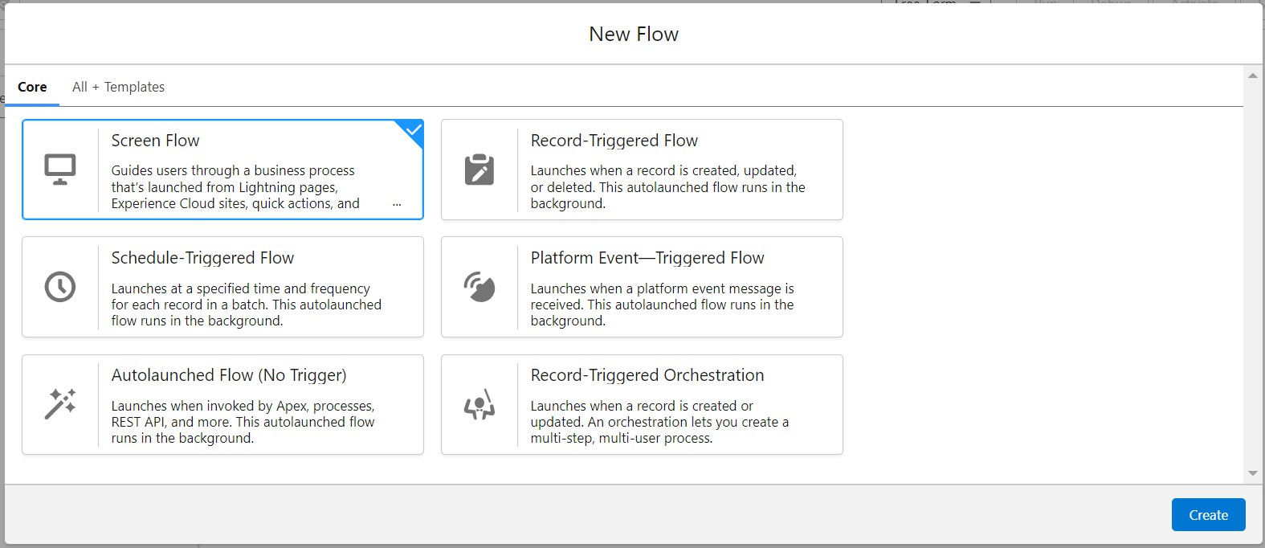

1. Click on the ‘+’ icon in between start and end, and click on screen element.
2. Under the Screen Properties: Label : Venue Details

API Name : Venue_Details

1. Now lets add components in this flow. Click on Text Component and name it as: Label : Venue Name

API Name : Venue_Name

1. Click on Email Component and name it as: Label : Email

API Name : Contact_Email

1. Click on Phone Component and name it as: Label : Phone

API Name : Contact_Phone

1. Click on Text Component and name it as: Label : Venue Location

API Name : Venue_Location

1. Click on Number Component and name it as: Label : Latitude

API Name : Latitude

1. Click on Number Component and name it as: Label : longitude

API Name : longitude

1. Next click on Done. This would like below

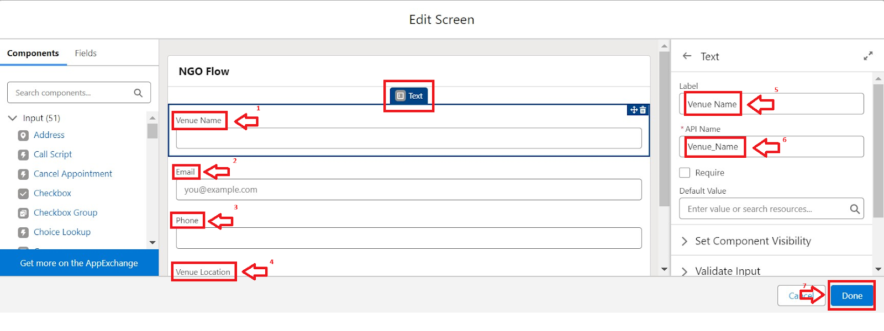

1. Click on the ‘+’ icon in between Venue details and end, and click on create record element.
2. Now label it as

Label : Create Venue Record API Name : Create_Venue_Record

How Many Records to Create : One

How to Set the Record Fields : Use separate resources, and literal values Object : Venue

Set Field Values for the Venue : Click on ‘Add Field’ 5 times Field : Value = Contact_Email c : {!Contact_Email.value} Field : Value = Contact_Phone c : {!Contact_Phone.value} Field : Value = Name : {!Venue_Name}

Field : Value = Venue_Location c : {!location} Field : Value = Location Latitude s : {!latitude}

Field : Value = Location Longitude s : {!longitude}

1. This would look like:

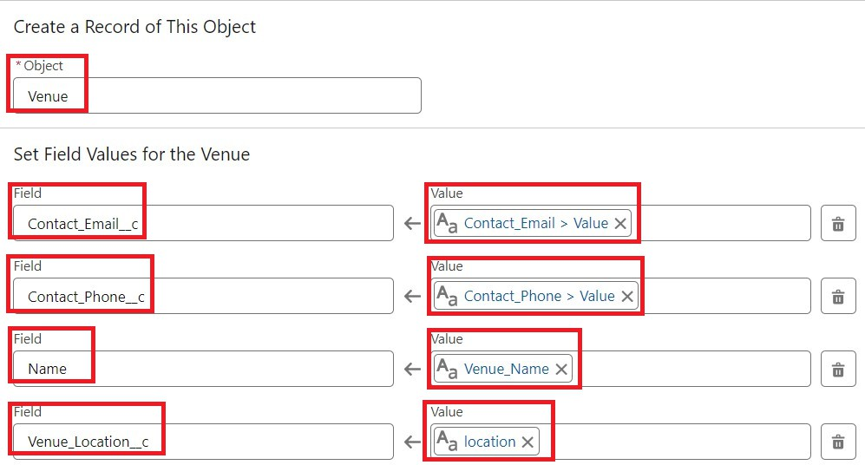

1. Click on Save as:

Flow Label : Venue Form Flow API Name : Venue_Form

**Task 7 :** Trigger

## Task 7 a : Create a Trigger

1. Log into the trail head account, navigate to the gear icon in the top right corner.
2. Click on developer console and you will be navigated to a new console window.
3. Click on the File menu in the toolbar, and click on new >> Trigger.
4. Enter the trigger name and the object to be triggered.

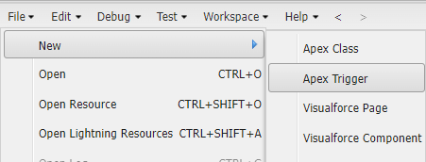

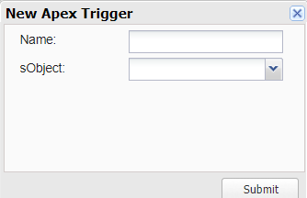

1. Enter Name : DropOffTrigger sObject: Drop-Off Point
2. Click on Submit.

## Task 7 b : Trigger Code

(This Trigger is to assign Distance field to the Distance Calculation field. So that we can assign the distance in the sharing rules.)

Code:

trigger DropOffTrigger on Drop_Off_point c (before insert) { for(Drop_Off_point c Drop : Trigger.new){

Drop.Distance c = Drop.distance_calculation c;

}

}

**Task 8 :** Profiles

1. Go to setup page >> type Profiles in Quick Find bar >> click on Profiles >> click on ‘S’
2. Click on Clone beside Standard Platform User.
3. Under Clone Profile:

Profile Name : NGOs Profile Then click on Save

**Task 9 :** Creation of Users

In our Project we consider them as NGO’s

#### Creation of User1

1. Go to setup page >> type users in Quick Find bar >> click on users>> New user.
2. In General Information give details as: (Note : create users as per your wish NGO’s)

First Name : Iksha Foundation Last Name : Iksha_Foundation Alias : iiksh

Email : Give Your Email

Username :[ikshafoundation@sb.com](mailto:ikshafoundation@sb.com)(give the username different) Nickname : Auto Populated

User License : Salesforce Platform Profile : NGOs Profile

Active : Check

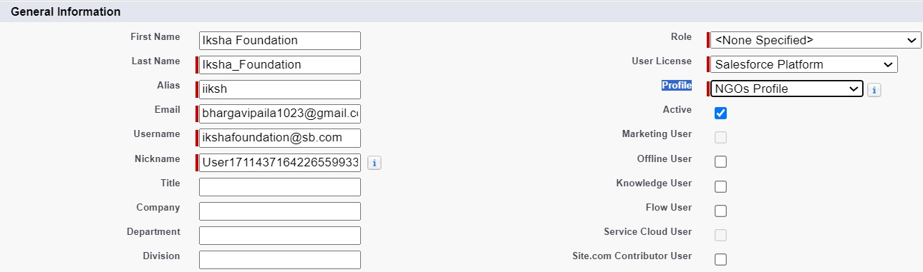

1. Click on Save

#### Creation of User2, User3

1. Create another Two Users by following steps in Activity - 1 with similar User License and Profile.
2. Give Different First Name, Last Name based on Different NGO’s.

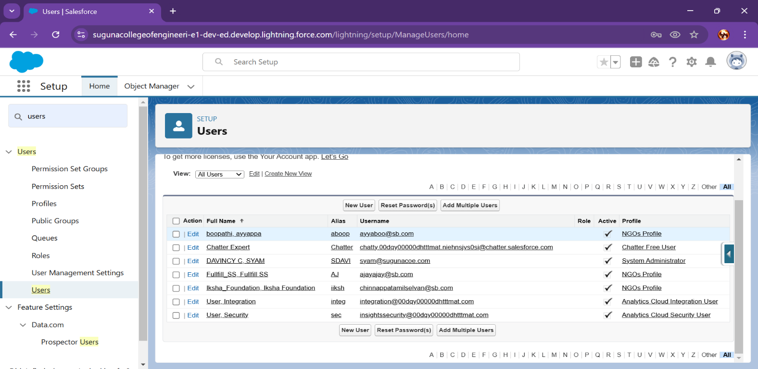

**Task 10 :** Public Groups

#### Task 10 a : Creation of Public Group 1

1. Go to setup page >> type Public Groups in Quick Find bar >> click on Public Groups >> click on New.
2. Under Group Information: Label : Iksha

Group Name : Iksha

Grant Access Using Hierarchies : Check

1. In Search, Select Users.
2. In Selected Members Add Iksha Foundation and System Administrator

#### Task 10 b : Creation of Public Group 2

1. By Following Steps in Activity 1, Create other two Public Groups for other two users.
2. After Saving this would look like this.

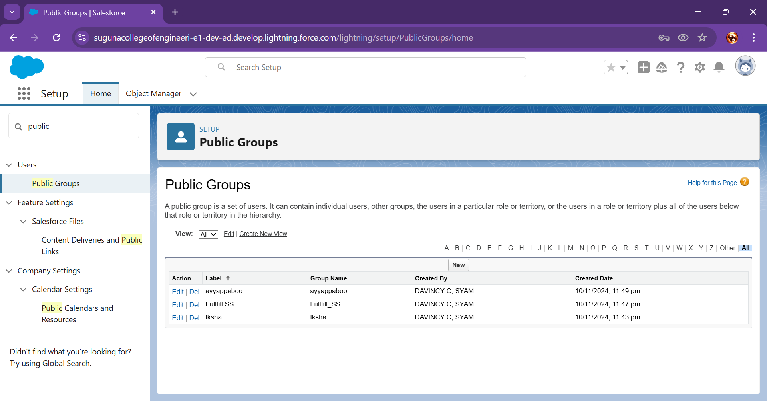

**Task 11 :** Report Types

#### Creation of Report Types

1. Go to setup page >> type Report Types in Quick Find bar >> click on Report Types >> click on Continue >> Click on New Custom Report Type.
2. In Define the Custom Report Type: Primary Object : Select Venues

Report Type Label : Venue with DropOff with Volunteer Report Type Name : Venue_with_DropOff_with_Volunteer Description : Venue with DropOff with Volunteer

Store in Category : Select Other Reports Deployment Status : Deployed

1. Click on Next
2. Near Click to relate another Object Select Drop-Off Points.
3. And also select "A" records may or may not have related "B" records.
4. Now again Near Click to relate another Object Select Volunteers.
5. Now click on Save.

**Task 12 :** Reports

#### Task 12 a : Creation of Report on Venue with DropOff with Volunteer

1. Go to the app(FoodConnect) >> click on the reports tab
2. Click on New Folder.

Folder Label : Custom Reports

Folder Unique Name : CustomReports

1. Open Custom Reports and click on New Report
2. Select Report Type : Venue with DropOff with Volunteer
3. Then click on Start Report.
4. In GROUP ROWS : Add Volunteer Name
5. In Columns : Add Venue Name, Drop-Off point Name, Distance.

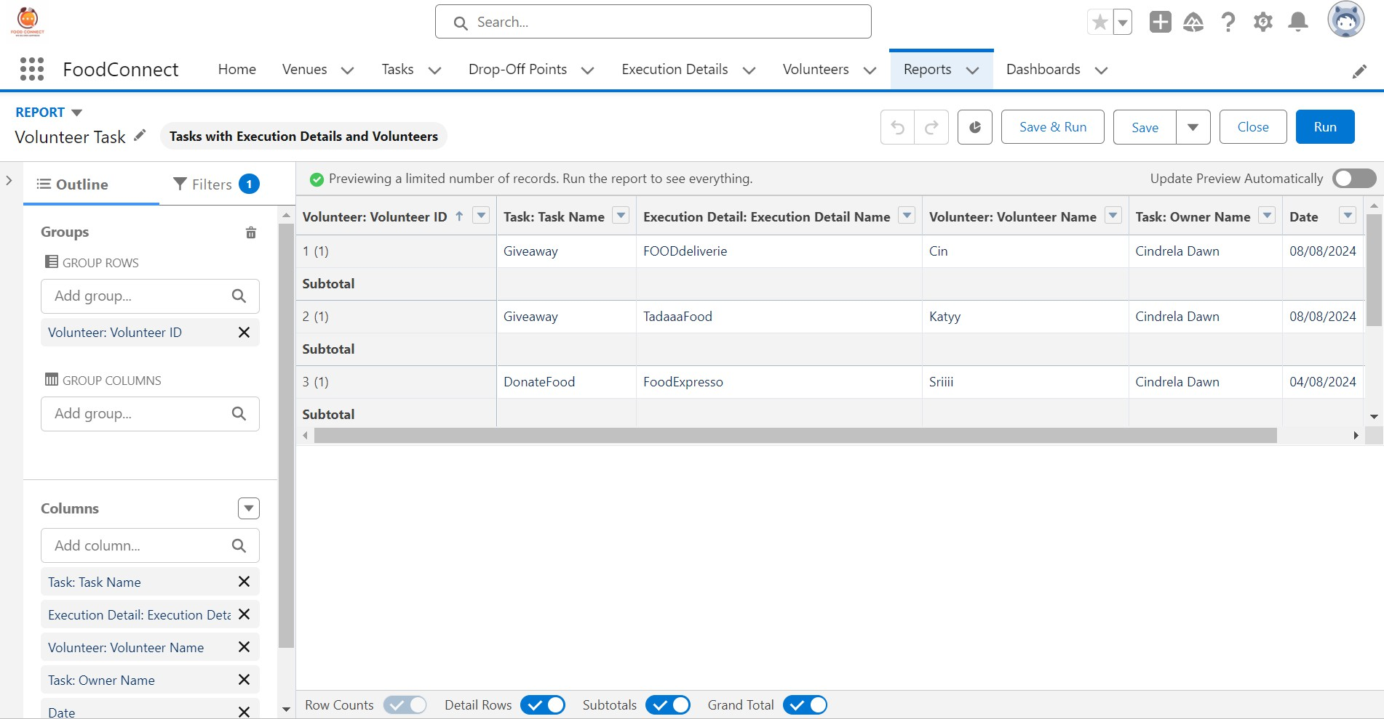

1. Now click on Save & Run.
2. Give Label as :
3. Report Name : venue and Drop Off point
4. Report Unique Name : Auto Populated
5. Click on Select Folder and select Custom Report, then click on Save.

#### Task 12 b : Creation of Report on Volunteers with Execution Details and Tasks

1. Go to the app(FoodConnect) >> click on the reports tab
2. Click on Custom Reports Folder and click on New Report
3. Select Report Type : Volunteers with Execution Details and Tasks.
4. Then click on Start Report.
5. In GROUP ROWS : Volunteer ID
6. In Columns : Add Volunteer : Volunteer Name, Task : Task Name, Execution Detail : Execution Detail Name, Volunteer: Owner Name, Task: Date, Task : Rating.

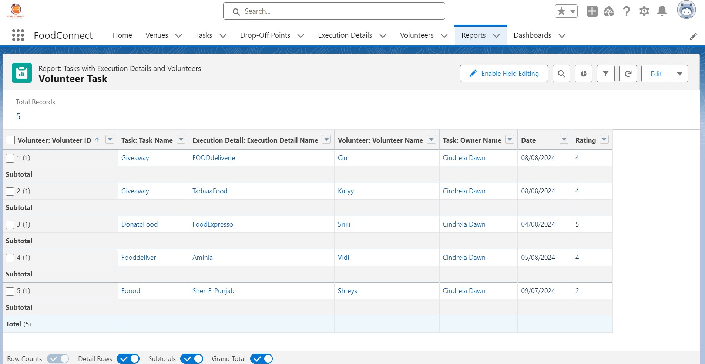

1. Now click on Save & Run.
2. Give Label as :

Report Name : Volunteer Task

Report Unique Name : Auto Populated

1. Click on Select Folder and select Custom Report, then click on Save.

**Task 13 :** Dashboards

Task 13 a : Adding venue and Drop Off point Report to the Dashboard

1. Go to the app(FoodConnect) >> click on the Dashboards tab.
2. Click on New Folder.

Folder Label : Custom Dashboards Folder Unique Name : Auto Populated

1. Open Custom Dashboards and click on New Dashboards
2. Name : Organization Details
3. Click on Widget and select Chart or Table
4. In Select Report : Select venue and Drop Off point Report.
5. Then click on select
6. In Add Component:

Display As : Select Lightning Table

Component Theme : Select Dark (Optional)

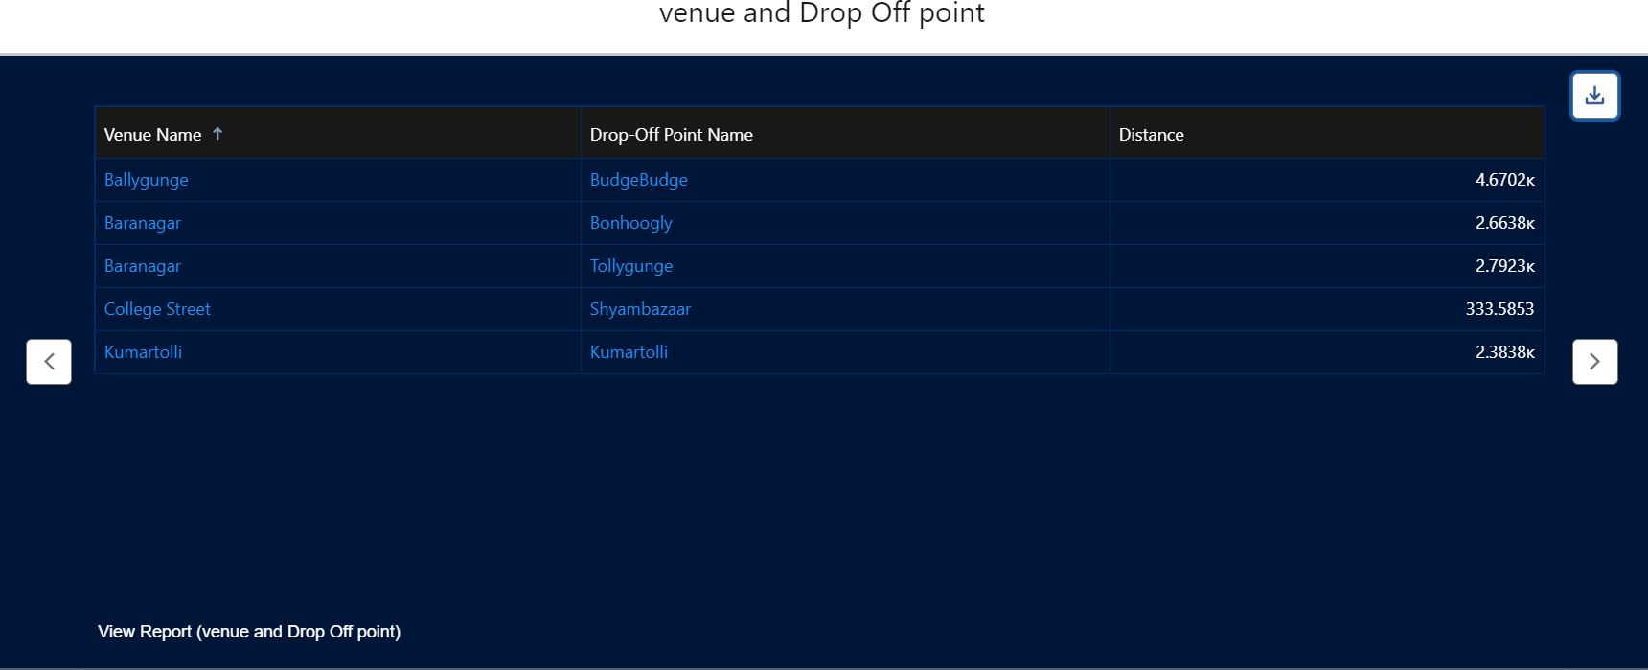

1. Now click on save.

Task 13 b : Adding Volunteer Task Report to the Dashboard

1. Click on Widget and select Chart or Table
2. In Select Report : Select Volunteer Task Report.
3. Then click on select
4. In Add Component:

Display As : Select Line Chart

Component Theme : Select Dark (Optional)

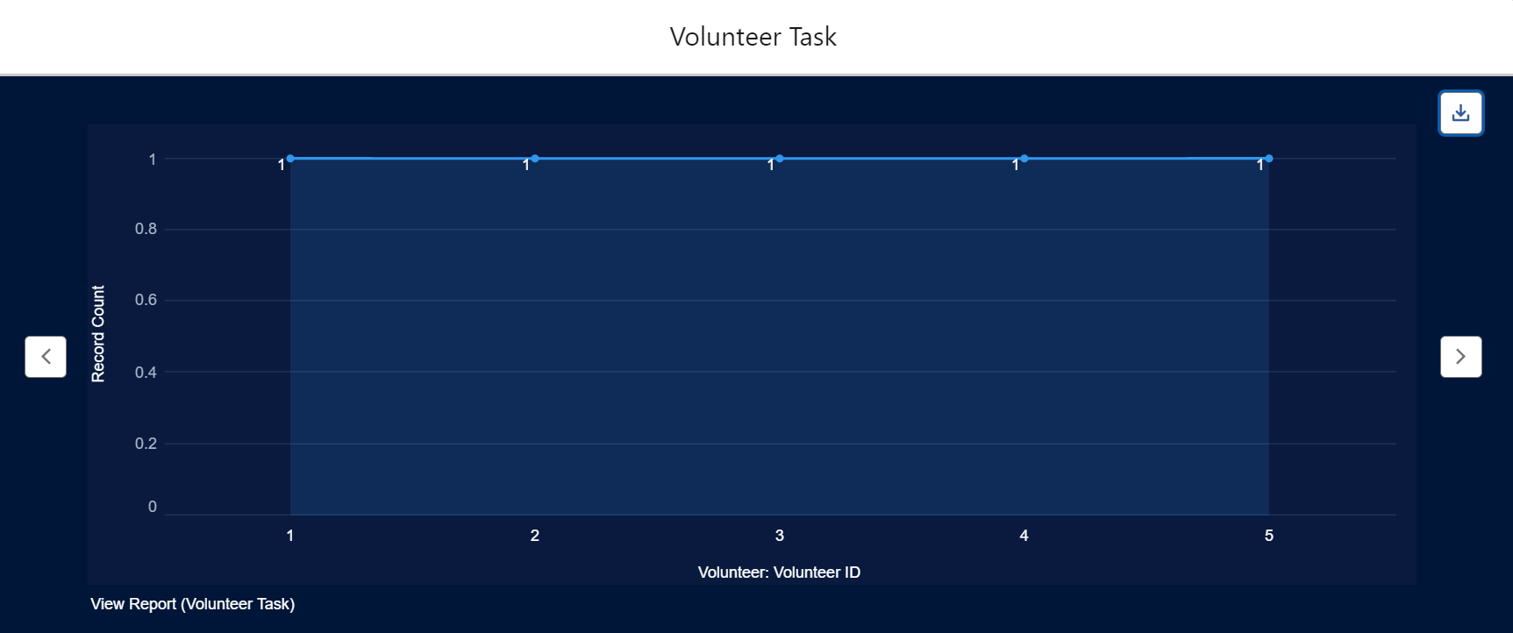

1. Now click on save.

Task 13 c : Adding a Picture to the Dashboard (Optional)

(Note : To upload an image into the Dashboard, we have to first download an image from google or other sources into your system)

1. Click on Widget and select Image. Then click on Browse Files.
2. Then Select the Picture you want to upload in this Dashboard.
3. Then click on Save As :

Name : Task Execution Details

Click on Select Folder and select Custom Dashboards

1. Click on Select Folder and then Save.

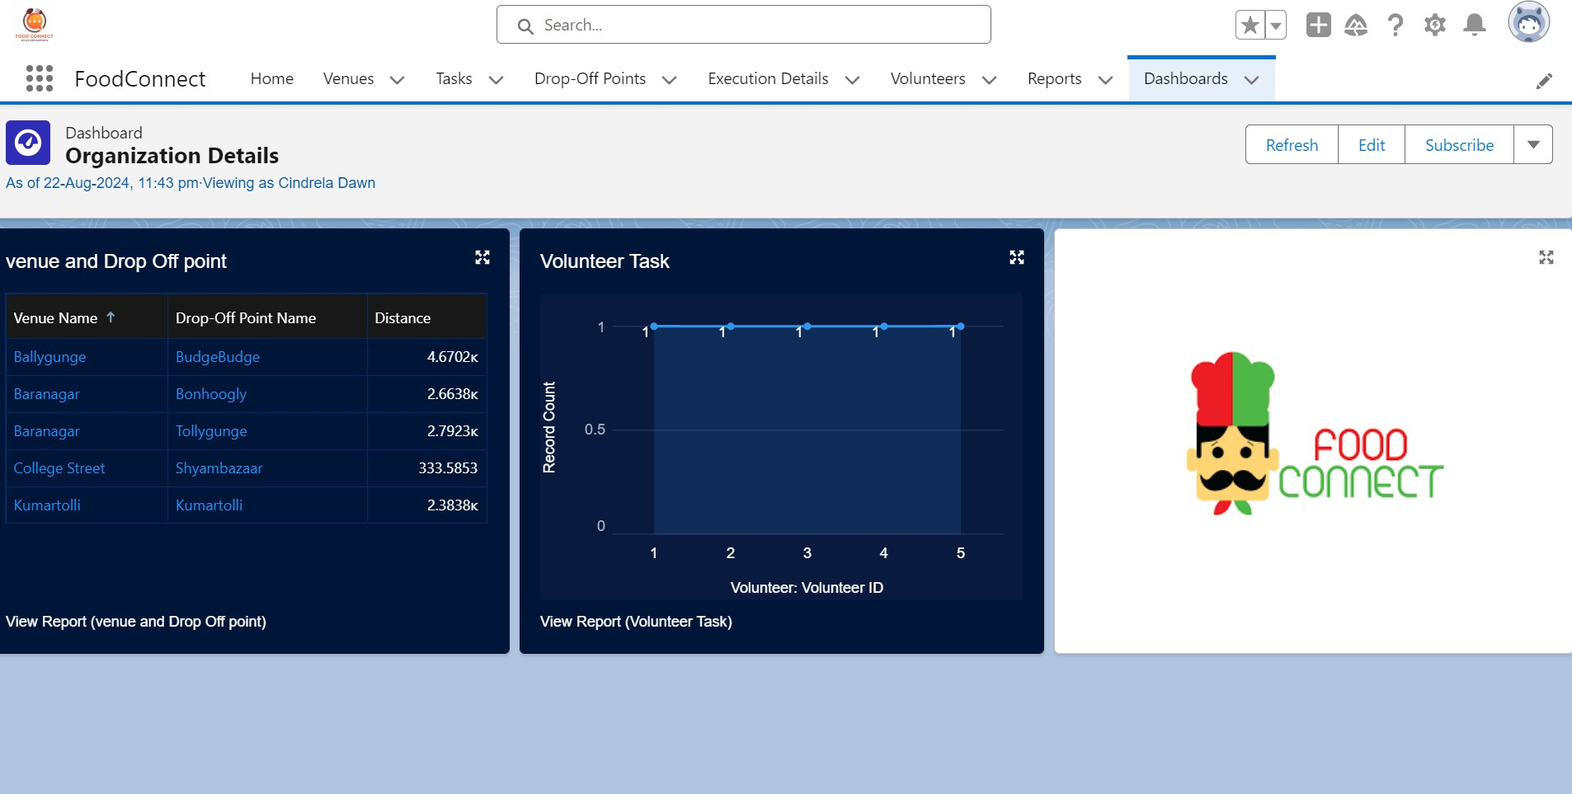

**Task 14 :** Sharing Rules

Creation of sharing rules

1. Go to setup >> type Sharing Settings in quick find box >> Click on the Sharing Settings.
2. Scroll down and find Drop-Off point Sharing Rules.
3. Click on new near Drop-Off point Sharing Rules and Name it as: Label : Rule 1

Rule Name : Rule_1

1. Select your rule type : Select Based on criteria.
2. Select which records to be shared:

Field : Operator : Value = Distance : less than : 15

1. Select the users to share with : Near Share With Public Groups : Iksha
2. Click on Save.
3. Click on new near Drop-Off point Sharing Rules and Name it as: Label : Rule 2

Rule Name : Rule_2

1. Select your rule type : Select Based on criteria.
2. Select which records to be shared:

Field : Operator : Value = Distance : greater than : 15 Field : Operator : Value = Distance : less or equal : 30

1. Select the users to share with : Near Share With Public Groups : NSS
2. Click on Save.
3. Click on new near Drop-Off point Sharing Rules and Name it as: Label : Rule 3

Rule Name : Rule_3

1. Select your rule type : Select Based on criteria.
2. Select which records to be shared:

Field : Operator : Value = Distance : greater than : 30 Field : Operator : Value = Distance : less or equal : 50

1. Select the users to share with : Near Share With Public Groups : Street Cause
2. Click on Save.

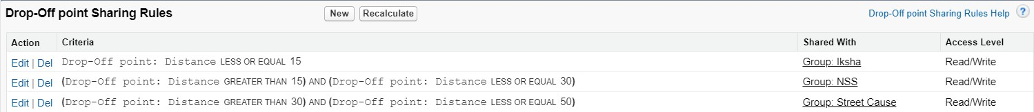

**Task 15 :** Home Page

#### Creation of Home Page

1. Go to setup >> type Lightning App Builder in quick find box >> Click on the Lightning App Builder and Select the New.
2. Select Home Page and give Label as HOME Page.
3. Select Standard Home Page.
4. Near Components search for Flow and Drag and Drop in Right Side Section.
5. On the right hand side:

Flow : Venue Flow

1. Near Components search for Dashboard, then Drag and Drop it in first Section.



1. Click on Save and Activation, then click on App Default, then Add Assignments.
2. Add FoodConnect App and then Save.
3. FoodConnect Home Page would look like this.

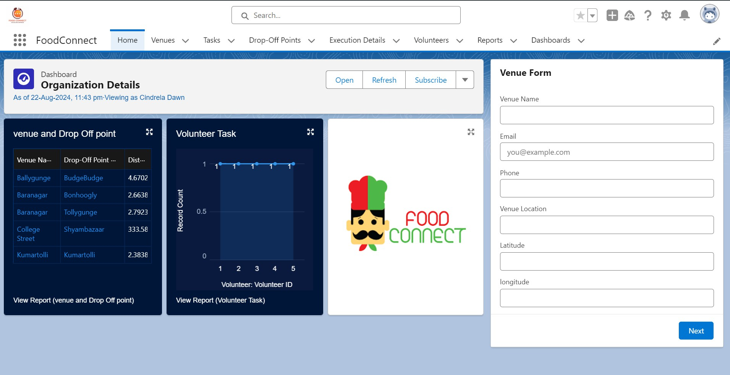

# Conclusion

By leveraging the Salesforce platform, the project successfully established a streamlined and transparent system for managing surplus food donations. Through efficient coordination with volunteers and timely delivery to beneficiaries, the project effectively addressed food insecurity while maximizing the utilization of available resources.

**Thank You**